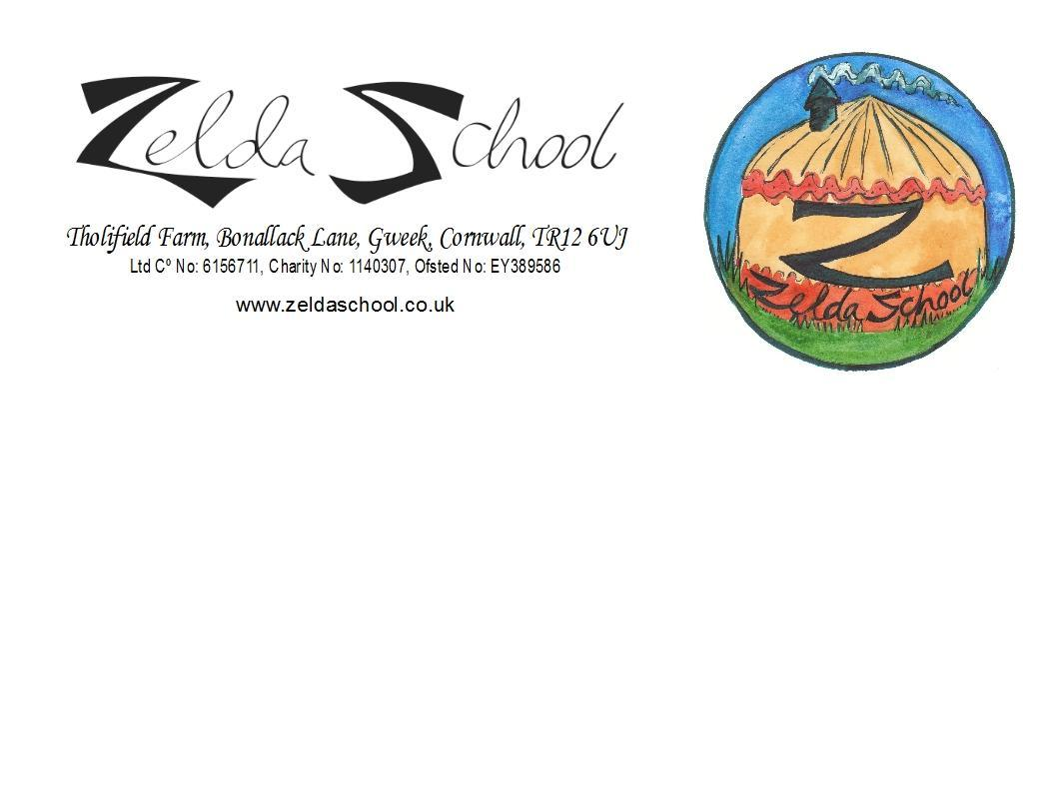
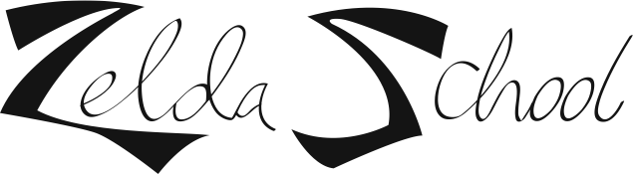
Admissions Policy

Statement of intent
Zelda School intends to be accessible to children and families from the whole community. Zelda School currently welcomes children from age 2 to the end of the year that they turn 7.
From September 2023 Children who are aged 2 will be required to leave at 1pm until they turn 3 years old.

Aim
We aim to ensure that the whole of the community have access to the setting through open, fair and clearly communicated policies including our Admissions Policy and Procedures.

Methods
In order to achieve this;

We ensure that the existence of the school is widely advertised in places accessible to all sections of the community.

We ensure that information about our school is accessible in written and spoken form, on the Internet and, where appropriate in more than one language. Where necessary we will try to provide information in Braille or through signing or an interpreter.

We describe the school and its practices in terms, which make it clear that it welcomes both fathers and mothers, other relations and carers, including child minders and foster carers. We are a family school and aim to make the school feel like a second home.

We describe the school and its practices in terms of how it treats each child and their family, having regard for their needs arising from gender, special educational needs, disabilities, social background, religion, ethnicity or because English is a newly acquired language.

We make our Equality and Diversity Policy clear and easily accessible.

Zelda School accepts 2 year old funding which Is currently 15 hours a week.

Criteria for eligibility for 2 year old funding

For more information and to apply for the funding please go to www.childcarechoices.gov.uk

Families who live in England and get the following benefits:
- Income Support
- income-based Jobseeker’s Allowance (JSA)
- income-related Employment and Support Allowance (ESA)
- Universal Credit, and your household income is £15,400 a year or less after tax, not including benefit payments
- the guaranteed element of Pension Credit
- Child Tax Credit, Working Tax Credit (or both), and your household income is £16,190 a year or less before tax
- the Working Tax Credit 4-week run on (the payment you get when you stop qualifying for Working Tax Credit)
2-year-olds can also get free childcare if they:
- are looked after by a local authority
- have an education, health and care (EHC) plan
- get Disability Living Allowance
- have left care under an adoption order, special guardianship order or a child arrangements order

From September 2017 The Department for Education (DFE) have extended the current free 15 hours of childcare (free to all families of 3 and 4 year olds) to 30 hours for eligible families. This is part of the drive to increase employment.
Combined with this initiative the government have introduced a national funding formula for The Early Years.

Criteria for eligibility for 30 hours funding
Families where both adults with whom the child is living are working (or sole parent is working in a lone parent family) and each adult earns, on average, a weekly minimum equivalent to 16 hours at national living wage and earning less than £100,000 per year. If at least one parent earns in excess of £100,000 the family will not be eligible. For more information and to apply for the funding please go to www.childcarechoices.gov.uk

Zelda School will offer up to 30 hours funded places for eligible families, which would cover the cost of a full time place at the school. A charge will still be applied for cooked lunches and snacks.

All families claiming funding at Zelda school, will need to show the school ID for the child/children they are applying for so we can verify their date of birth- this must happen before the child starts.

In line with Government legislation Zelda School is currently only able to accept a maximum of four full time children of compulsory school age. We are unable to offer full time places to children with an Education and Health Care Plan or Looked After Children due to Government legislation.
Children of compulsory school age, who are attending Zelda School part time will be required to register as Elective Home Educating, unless they are also attending a maintained school or academy as part of a flexi-schooling arrangement.

In the event of a waiting list Zelda School operates an admission procedure as agreed by the trustees, available on the website and on request.

We arrange our admissions waiting list in the order we receive applications, only giving priority to the children of staff, children already attending the school who wish to increase their hours and siblings of children currently attending the school.

Any persons wishing to apply to join Zelda School should contact the school on 07400 576 116 or via the website www.zeldaschool.com

Policy agreed by Directors on: ________________________________________

Signed:

_______________________________ Policy to be reviewed on: __________________

Zelda School
Admissions Procedures

Places at Zelda School will be prioritised as follows:

In all classes:

- Children of staff who are working at the school.

- Children who attend Zelda School already and whose parents or carers wish to increase the number of sessions they attend.

- Siblings of children currently attending Zelda School getting priority for available spaces

- The order in which applications were received – first come first served.

In Lower Kindergarten:

- Places will be offered to new two, three or four year olds who will receive Government Funding, for whom we have received an application form and who are on our waiting list.

In Upper Kindergarten:

- Places will be offered to those already attending and wish to increase their hours, with an awareness that we have limited full time spaces available.

- Next places will be offered to children for whom we have received an application form and are on our waiting list.

- Before places are offered, reports may be requested from the child’s previous school or childcare setting.

NB:
We are unable to offer full time places to school aged children with an Education and Health Care Plan or Looked After Children due to Government legislation.

Consideration will be given to the needs of all the children in the class before new children are offered a place. We are aware that some children require more support and have more needs than other children and we will only offer a place to a new child if we feel that we can meet all the children’s needs.

The order in which applications were received will always be used, but priority will be given to those children who have a sibling currently attending Zelda School.

When a place becomes available at Zelda School the parents will initially receive a phone call offering a place for their child. They will have 2 weeks to decide if they would like to accept the place before we offer the place to the next person on the waiting list.
After confirming the wish to take up a place at Zelda School parents will receive a confirmation letter, a Parent Handbook with information about how the school works and what to expect and information about financial and non-financial contributions in the Contribution Agreement.
It is now a legal requirement that the school sees proof of a child’s age, in order to apply for funding, when they start at the school. No copies will be taken of the proof, but this must be a legal document e.g. a passport or birth certificate.

